Penetrance and Expressivity

Penetrance
Penetrance is how often a gene finds expression in a population. It expresses as a percentage of the population has the gene that develops corresponding phenotype. If there is a gene with low penetrance, it may not be expressed even when the trait is dominant. Moreover, it may not be expressed when the trait is recessive, and the gene responsible for the trait is present on both the chromosomes. Though many persons may be carrying the gene, penetrance may vary from person to person and its expression may also dependent upon a person’s age. So, if an abnormal allele is not visible in a person but he is a carrier, he can pass the allele to children who may have an abnormality.
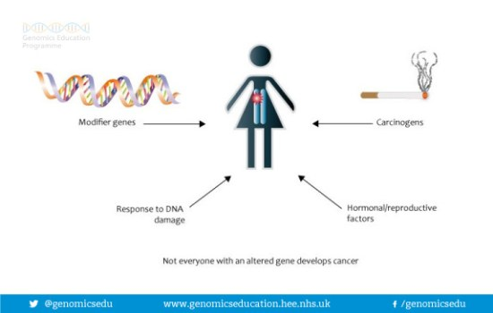
Penetrance will be 100% if all the individuals in the population show the expected phenotype. When it is below than 100%, we call it incomplete penetrance. Incomplete penetrance is very common. Though everyone in a population carries the same allele, not all individuals are capable of showing the expected phenotype. It may be due to several reasons such as modifiers, epistatic genes, or suppressors in the rest of the genome or because of a modifying effect of the environment etc.

Expressivity
Expressivity is the intensity of the expression of a gene in an individual. In simple words, expressivity refers to the extent to which a gene expresses in a single individual. It is also a percentage measurement. For example, if a gene has 75% expressivity means, the individual only shows a ¾ of the features of that trait. On the other hand, an individual showing 100% expressivity means, the correct phenotype with all the features is present in an individual.
Hence, expressivity determines how much the trait affects or the extent to which the features of a trait are apparent in an individual. Therefore, expressivity can range from zero to 100% and is dependent upon many factors such as genetic makeup, environment (exposure or intake of harmful substances), and even the age of the person.
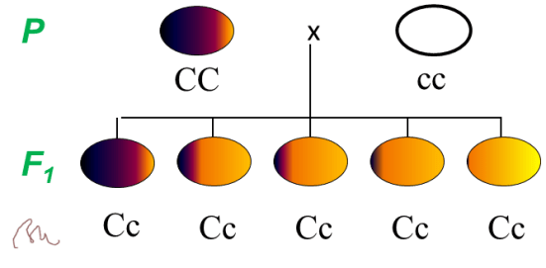

Difference between Penetrance and Expressivity
Penetrance and expressivity are two measures that determine the variability of genotype and phenotype relationship. Although the genotype is present, the phenotype may not appear, or it may appear only in some individuals in a population. Also, the intensity may vary. Penetrance measures the proportion of genotypes that actually show expected phenotypes. On the other hand, expressivity measures the intensity of the phenotype expression in a single individual. Hence, this is the key difference between penetrance and expressivity.
Furthermore, another difference between penetrance and expressivity is that the penetrance describes statistical variability among a population of genotypes while the expressivity describes the individual variability.

